FINAL REPORT FORMAT

Contents
Title Page
Acknowledgement
Declaration and Recommendation
Letter of Approval
Abstract
Table of Contents
List of Tables
List of Figures
Abbreviations
- Introduction
- Problem Statement
- Objectives
- Background Study
- Requirement Document
- System Design
- Development
- Testing
- Project Result (Should supplement this topic with a Demo)
- Future Enhancements
- Conclusion
- Annex

4. Formatting Guidelines

4.1 Paper
Use A4 size white paper and print only on single side of the paper.

4.2 Length of the Report
It depends on the nature of the project. The valid length is under the jurisdiction of the supervisor and the department.

4.3 Margins
Left side: 1.5 inch, Right side: 1 inch, Bottom: 1 inch, Top: 1 inch

4.4 Font
Times New Roman, Black

4.5 Font Size
Heading 1: 16, Bold, Space Before: 12 pt, After: 12 pt, Keep with next, Keep lines together, Every context word should start with Uppercase,
Heading 2: 14, Bold, Space Before: 12 pt, After: 12 pt, Keep with next, Keep lines together, Every context word should start with Uppercase
Heading 3: 12, Bold, Space Before: 6 pt, After: 6 pt, Keep with next, Keep lines together , Every context word should start with Uppercase
Heading 4: 12, Normal, Every context word should start with Uppercase
Main Text: 12, Normal and Justified, Italics and Bold are permitted for emphasis as and when required.

4.6 Line Spacing
1.5 lines

Paragraph
No indentation

4.8. Page Number
At the right of the page, Times New Roman, 10, Black, Normal

4.9 Pagination
Natural numbers (1,2,3,…) from first page to end of the report including Annex. Roman numbering in the introductory pages like Acknowledgement, Table of Contents, List of Tables, List of Figures, and other if any.

4.10 Table and Figure labeling
Table Section No.Table No – Table Name, Times New Roman, 10, Normal, center
e.g., Table 4.10.1- Table Naming Example
Figure Section No.Figure No – Figure Name, Times New Roman, 10, Normal, center
e.g., Figure 4.10.1 – Figure Naming Example

4.11 Binding
Proposal: Tape Binding (1 Copy during defense and after defense, 2 copies of finalized version of the proposal with correction need to be submitted to the college).
Mid Term Progress Report: Tape Binding (1 copy to the supervisor)

Final Project Report:
For 2nd and 4th Semester
Tape Binding (Total 4 Copies: Pokhara University – 1 Copy, College – 2 Copies, Student – 1 Copy). No. of student copies may differ according to the number of members in the project group.
For 6th and 8th Semester
Hard Binding (Total 4 Copies: Pokhara University – 1 Copy, College – 2 Copies, Student – 1 Copy). No. of student copies may differ according to the number of members in the project group.


LA GRANDEE INTERNATIONAL COLLEGE
Simalchaur, Pokhara Nepal
A Project Proposal
On
“[Title]”

Submitted to:
Bachelor of Computer Application(BCA) Program
In partial fulfilment of the requirements for the degree of BCA under
Pokhara University
Submitted by:
Name: | Course | Semester | P.U. Registration Number
Aastha Gc | BCA | 2nd | 2025-1-53-0312
Shital Thapa | BCA | 2nd | 2025-1-53-0348
Date:16/06/2026

Acknowledgement
The satisfaction that accompanies after the successful completion of any task will be incomplete without mentioning the people whose ceaseless and relentless cooperation, constant guidance and encouragement made this project possible.
We are grateful to our project supervisor Mr Arpan Pokhrel, our faculty teacher Mr. Ramesh Chalise, for the guidance, inspiration and constructive suggestions that helped us in the preparation of this project.
We are also appreciative among each other and have understood that teamwork, the designation of the task per the skillset one portrays, constant synchronisation and monitoring of progress and instilling new knowledge and skill is imperative for the success of any given work.
Sincerely,
Astha GC
Shital Thapa

Declaration for
“Project Title”
Student’s Declaration
I (We) hereby declare that I (we) am (are) the only author(s) of this work and that no sources other than the listed here have been used in this work.
____________________________
Name of the Students
NAME, EXAM ROLL NO
Program, Semester
Date:____ / ____ / ________

Supervisor’s Declaration
I hereby recommend that this project entitled “Project Title” is done under my supervision by Student Name1 and Student Name 2 during their _th Semester in partial fulfilment of the requirements for the degree of Program Name under Pokhara University is completed to my satisfaction and be processed for final evaluation.

____________________________
Name of the Supervisor
Date:____ / ____ / ________

Letter of Approval
We certify that we have examined this report entitled “Project Title” and are satisfied with the project defence. In our opinion it is satisfactory in the scope and qualify as project in partial fulfilment of the requirements for the degree of Program Name under Pokhara University.

________________________  Supervisor  Arpan Pokhrel | ________________________  Examiner  Date:____ / ____ / ________ | ________________________  Program Coordinator

TABLE OF CONTENT
ACKNOWLEDGEMENT ii
STUDENT’S DECLARATION iii
SUPERVISOR’S DECLARATION iv
1. INTRODUCTION 1
2. PROBLEM STATEMENT 2
3. OBJECTIVES 3
4. METHODOLOGY 4
5. DATA FLOW DIAGRAM 5
6. PROJECT GANTT CHART/ TIMELINE CHART 6
7. DELIVERABLES 7
8. CONCLUSION 8

LIST OF FIGURES
Figure 1Use case of Fine Management 15
Figure 2Waterfall model 16
Figure 3Gantt Chart 17

ABBREVIATIONS
A/D | Analog-to-Digital
ABC | Atanasoff Berry Computer
ACM | Association for Computing Machinery
AI | Artificial Intelligence
ALGOL | Algorithmic Language
ALU | Arithmetic Logic Unit
AMD | Advanced Micro Devices
ARPANET | Advanced Research Project Agency Network
ASCII | American Standard Code for Information Interchange
BASIC | Beginners All-purpose Symbolic Instruction Code
BCD | Binary Coded Decimal
BIOS | Basic Input Output System
BIPS | Billions of Instructions Per Second
BPI | Bytes Per Inch
CAD | Computer Aided Design
CAE | Computer Aided Engineering
CAN | Campus Area Network
E.G. | Example

Introduction
Student Fine Management system is a software project used to manage student fines in school/colleges and other many educational institutions. It helps to keep records of fines , Payments and student details in an easy and organised way. The system reduces manual work, save times, and improve accuracy in maintain fine records. It is useful for tracking paid and unpaid fines efficiently. In many institutions fines are imposed on students for various reasons such as late payment of fees, library book delays, breaking institutional rules, or failure to submit assignments on time. These fines records are maintained manually in registers or paper files which is a time consuming process. The student fine management system provides a digital platform where administrators can easily manage all fine related activities. The system allows the admin to store student information, add new fine record, update payment status, search student details, and generate reports whenever required. By using this system, educational institutions can reduce paper work and improve the accuracy and efficiency of fine management.
The system is designed in a simple and user friendly manner so that it can be easily used by administrative staff without requiring advance technical knowledge. Each student is assigned a unique identification number through which there fine details can be accessed quickly. The system also helps maintain transparency because students fines record can be stored systematically whenever necessary. The student fine management system generally consist of different modules such as student management, fine management, payment management. The student Management module stores basic student details such as name, roll no, class and contact information. The fine management module records the type of fine, amount, date and reason of the file. The payment management module keeps track of whether the fine has been paid or not. The report module helps generate summarizes of collected fines and pending dues.
Traditionally, fine management systems in many institutions are handled manually by administrative staff. This manual process requires a lot of paper work and continuous effort to update records regularly. As the number of students increases, maintaining fine records becomes more complex. There may be problems such as loss of records, duplicate entries incorrect calculations, difficultly in searching student details and delays in updating a payments status. In addition, generating reports about collected fines and pending dues becomes challenging in a manual system. Therefore, there is a need for an automated and computerized system that can manage student fine records accurately and efficiently.
The student fine management system is develop with the objective of simplifying the fine management process and improving administrative efficacy. The system stores all information in a data base, which allows easy retrieval and modification of records. Each student is assigned a unique identification number or roll no, making it easier to access there fie details quickly. Administrators can also keep track of paid and unpaid fines, which helps maintain transparency and accountability with in a institution.
For our project, we divided work between us from the beginning. Documentations and coding was divided between all of us. Mainly, Gantt chart was sketched and requirement traceability matrix was done by Aastha G.C. similarly, Flowchart and DFD was graphically designed by Shital Thapa. Research about project related information and testing platform and was handled by Arpan Pokhrel. However, each member contributed to the coding and testing of each module and provided there variable inputs to improve the system.
While doing research we knew that thee were many difficulties regarding collection of data, multiple set booking, data was in accurate, adaptation in system according to government policy was difficult while changing. By keeping this difficulties we made this system and we were successful to minimize this difficulties using C++.
Going digitally is one of the great idea in this time period because each and every thing has been digitalized and many of the work pressures will be overcome, work will be much faster and we will be able to find each and every thing in much more efficient way. We will be able to deliver better experience for our customers. Analysing of data will be much more easier, so going digitally is best method.

Problem Statement
There were many difficulties as this was our first programming based project. Although there were many problems we were able to solve an implement it on our project. Lots of errors and many failures occur while attempting the entire task given in this project. Data collection, multiple seat booking, data was inaccurate, adaptation in system according to government policy and organizational change were difficult in the existing system. So to overcome these difficulties our program was intended.
At beginning people use to store/write data in manual form which results misplaced or loss of data. Previous system used to take a lot of spaces, prone to damage and being misplaced, hard to make changes, take a lot of access time, lack of security, higher cost, large on-going staff training cost, system id dependent on good individual, misinterpretation among peoples.
List of the following issues as secondary but prominent issues- can make problem statements in both micro and macro-level.
- Manual fine management is time-consuming.
- Paper records may cause errors and data loss.
- Difficult to track paid and unpaid fines.
- Students may not receive timely fine updates.
- No centralized system for fine management.
- Manual fine calculation can create mistakes.
- Report generation is slow and inefficient.

Objectives
A student fine management system is designed to automate and simplify the process of managing fines imposed on students in educational institutions. It helps administrators keep proper records, track payments, and ensure transparency in the fine collection process.
- To automate the process of managing student fines.
- To maintain accurate and organized fine records.
- To reduce manual work and save time for administrators.
- To track paid and unpaid fines easily.
- To minimize errors in calculation and record keeping.
- To provide quick access to student fine details.
- To generate reports efficiently when required.
- To improve transparency and accountability in the system.

Background Study
The background section should discuss your findings in a chronological (Sequential Manner) manner to accentuate the progress in the field and the missing points that need to be addressed.
The project background should include information about the reasoning why you want to implement this specific project in this specific location in this specific manner. It must explain the current situation and its problems and the way in which you want to solve these problems.
The student Fine management system is developed to replace traditional manual methods used in educational institutions for managing student fines. In many schools and colleges, fines related to late submissions, rule violations, or library delays are sill recorded using paper registers or basic spread sheets. This often leads to errors, data loss, and difficulty in tracking records efficiently.
Earlier studies on student management systems show that manual processes are the time consuming and inefficient, especially as the number of students increases.
Educational institutions face challenges in maintaining accurate records and generating reports without an automated system.
Research also shows that computer based student management systems help in organizing student data, improving accessibility and reducing administrative workload.
Similarly, studies on fines and fee management systems highlight that manual fine collection often causes confusion, lack of transparency, and difficulty in tracking payments. To solve these issues, automated systems are developed to ensure proper record keeping and easy monitoring of dues.
In conclusion, the background study shows that there is a strong need for a computerized student fine management system to improve accuracy, save time, reduce workload, and increase transparency in educational institutions.

Requirement Document
5.1 Functional Requirements
- Add student fine records.
- Update an delete fine details.
- Store student information and fine reason
- Track paid and unpaid fines.
- Search student fine records.
- Update payment status
- Generate fine reports(daily/monthly/Yearly)
- View student fine history.

2.Non Functional requirements
- User friendly system
- Fast performance
- Secure data storage
- Authorized access only
- Reliable operation
- Easy maintenance
- Accurate record handling
- Backup and recovery support
- Simple interference
- Efficient processing

System Design
You can use the system design you have created in the mid-term report, basically we need to show the system design via two methods.
- Data Flow Diagram
In the case of DFDs, do not include context level diagram rather use level-1 or level-2 DFD, given the limited time you guys have one may use the correctly amended DFD diagrams.
- Flowchart
Make sure, the flowchart encompasses all the components of the project, the best approach would be creating flow chart for the CRUD operations what you use for the data-entry, data selection, data modification and deletion.
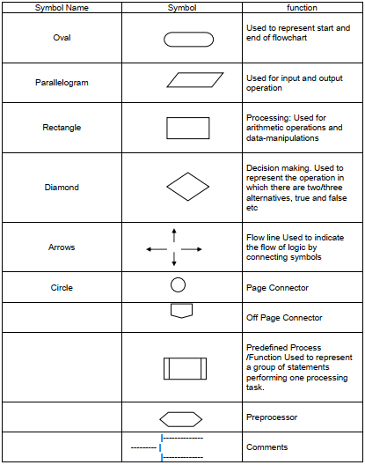
Try to use all the symbols properly, it is quite easy once you get a hang of it.

Development
Here, development refers to the model you have used for the project, for instance, waterfall, spiral, however, this section is not limited to the model only. Here, you need to describe the model you have used – SDLC.
Development may also refer to the entirety of process of planning, organizing, coordinating, and controlling the resources to accomplish specific goals. You can include the development environment (IDE) you choose and with reasons why, the tools you used for documentation, system design, and Gantt charts (or other scheduling charts).
What collaboration platform you have used, also describe the reason why, for example, you might have used SLACK, GIT or other repositories, Microsoft Teams with your project supervisor or your team members.
Do not forget the development paradigm is based on system designs too, you must religiously follow the system design and must not divert from the designs.
Finally, most importantly, the chart of work assignment.
S.N. | Name of the member | Work assigned | Remarks
1. | Your name | Documentation and coding.  - DFD  - Problem Identification  - Coding support  - Support in system design.
2. | Name | Documentation and coding.  - Gantt Chart  - Coding of login system  - Support in system design.  - Feasibility analysis.
3. | Name | Documentation and coding.  - Designed Flowchart.  - Coding for seat selection.  - Support in system design.  - Logic definition.

Testing
Mention the testing methodology you have used, make sure that we follow the testing paradigm, or software testing life cycle when we test a prototype or module.TLC stands for Software Testing Life Cycle. STLC is a sequence of different activities performed by the testing team to ensure the quality of the software or the product.
The main Motive behind Testing is that the tester or developers must be able to understand the client’s requirement, and thoroughly inspect the modules to create a positive and negative test cases.
- STLC is an integral part of Software Development Life Cycle (SDLC). But, STLC deals only with the testing phases.
- STLC starts as soon as requirements are defined or SRD (Software Requirement Document) is shared by stakeholders.
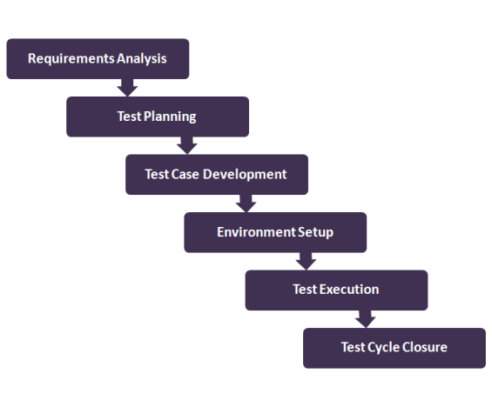
- STLC provides a step-by-step process to ensure quality software.
Figure 1: Software Testing Life Cycle
There are 6 major phases of STLC −
- Requirement Analysis − SRD is ready and shared with the stakeholders, the testing team starts high level analysis concerning the AUT (Application under Test).
- Test Planning or Execution− Test Team plans the strategy and approach, can be forward testing, backward testing, concurrent testing, modular testing.
- Test Case Designing − create the test cases based on scope and criteria.
- Test Environment Setup − When integrated environment is ready to validate the product.
- Test Execution − Real-time validation of product and finding bugs.
- Test Closure − Once testing is completed, matrix, reports, results are documented.

EXAMPLE OF A TEST CASE,
can use matrix or can use like this
Here is an example of a software test case:
Title: Module Testing of a Login function– Authentication of users
TID: 001, 002, 003
Description: A user should be able to log in with proper username and password
Precondition: The user must have username and password that is previously registered.
Test Steps:
Open the Executable file of the project, navigate to the login panel
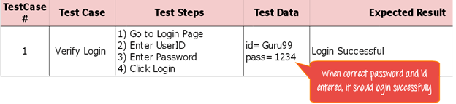
Enter random strings, zero values, null values, Capitalised strings, functions within functions, check whether it redirects to authorised sections.
Figure 2: Test Case using Matrix

A Test Matrix with Tested modules or Requirement Traceability Matrix
Requirement Traceability Matrix (RTM) is a document that maps and traces the user requirement with different test cases.
It collects all requirements addressed by the client or the requirement analysts and requirement traceability in a single document, delivered at the conclusion of the Software development life cycle.
S.N | Requirement Description | Testcase ID | Status | Remarks if any:
101 | Login into the application | TC01, TC02 | TC01- Pass  TC02- Fail | Changes needed in masking the password
102 | ID Creation | TC03 | TC03- pass | No changes required
103 | Ticket Search | TC04, TC05, TC06 | TC04- Pass  TC05- fail  TC06- Pass | Search mechanism failed.

NOTE: UAT(User Acceptance Testing) must be addressed in the final report, so here it is not required in mid-term report.
User Acceptance Testing (UAT), also known as beta or end-user testing, is defined as testing the software by the user or client to determine whether it can be accepted or not. This is the final testing performed once the functional, system and regression testing are completed.
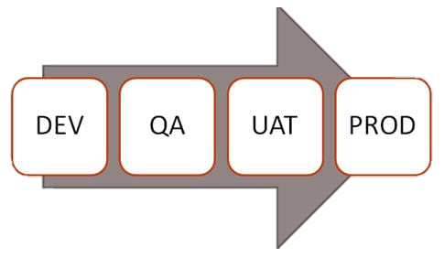
No. | Acceptance requirement(USR) | Critical (DEV) |  | Test Results(DEV) |  | Comments(USR)
 |  | Yes | No | Accept | Reject
1. | The login system should ensure security | Affirm. |  | Affirm |  | The system is felt secured.
2. | The results must be correct for inventory | Affirm. |  | Affirm. |  | The results were correct

Finally, include the user’s note or the supervisor’s note that the system works well and still a lot of updates are required for the future enhancements.

Project Results
Here in this section, you must put forward the results, on the basis of the following:
The Movie Ticket Management System project was conceptualized for the easiness during ticket purchase, food purchase as well as to end repetition, confusion during seat booking for the users. The functions which we visualized during the project were completely achieved.
The problems that have been solved with the project are:
>Time consumption during purchase of ticket and food is reduced.
>Probability of reoccurrence of booking same seat is terminated.
>Data are stored in a proper way, customer details and transaction details are quickly and comfortably found.
>Data can be copied simply and can be stored in multiple places which lower the risk of data loss.
After the background study about the manual ticketing systems, we got information about the drawbacks of manual system and by designing different features in digital system we tried to put an end to it and through our system following market necessity were met:
>Reduction in large numbers of staff in ticket counter.
>Customers are provided fast service and customers detailed were easily generated.
>After the proper management of customer details, sales report and cut off in usage of large quantities pen and papers profit is achieved.
>Data errors were speedily decreased such as repetition of customer details or forgotten of customer details.
>Clarity and consistency in operation is seen.
At the beginning of project, we were unfamiliar about the C Programming and we were having fear about the project risks. This project work has been a difficult task as well as very fruitful one as there were a lot of new and useful topics that we got to interact. This project helped us to share and present our ideas in the group as well as help us to know about “How the teamwork works”. Spiritually throughout the project journey we acquire knowledge that everything can be learnt with passion and patience. Similarly, we developed friendly bond than the beginning.

Future Enhancements
If we get enough time then we will create a new feature of mobile transaction.
- Include GUI interfaces
- Use Databases
- Use complex data structures.
- Socket programming and computer to computer networking of data
- Barcode software
- More features like data manipulation and data reporting
Basically, think of the possibilities in the future and write it down. Can be brief, or a longer paragraph to describe what can be done. It is up to you.

11. Conclusion
Final, summary of the documentation, write down the most important components and findings. of each headings.

12. Annexures
Supplementary documents, snapshots, source codes, formula, important logics, conversation with the end-users.

